Current Operable Unit 3 Remedial Progress for Phase II Week Ending 5/7/10
Creamer Environmental Inc., National Grid’s Remediation Contractor, has finished relocating field operations to the north side of the site where the LIRR tracks were relocated back to their original location and also completed the mobilization of construction equipment, materials, and temporary facilities to the site. Phase 2 sheet pile installation will be complete by week ending 5/14. Creamer will start installing the internal bracing system (Walers) to the sheet pile line; this will include pre-excavation, transportation and disposal (T&D) of materials to Bay Shore Soil Management (formerly ESMI of NJ) for thermal desorption.
GEI, National Grid’s Remediation Oversight Consultant, will continue to perform CAMP (Community Air Monitoring Program) and Noise and Vibration monitoring. CAMP and Noise and Vibration monitoring will continue throughout the project.

Two-Week Outlook
Creamer Environmental Inc. will continue to install the Waler system in each of the four cells for the next few weeks, which will include partial excavation and T&D of materials. Once each cell is completed with the Waler support system, Creamer will then excavate to design depth followed by backfilling the excavation.
General hours of operation will continue to be Monday through Friday, 7:00 AM to 3:30 PM. However, work hours will be extended when necessary to maintain schedule or to complete critical tasks.
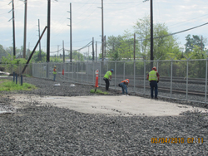
Installing 1st sheet pile
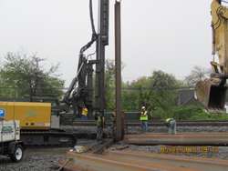
Installing 1st sheet pile

